As a Communication and Psychology double major, I undertook a number of multidisciplinary research projects during my undergraduate years, through which my keen interest in the dynamic interactions between the human brain and mediated messages has been promoted step by step. However, through my professional and lab experiences, I realized that, without strategic use of data, any attempt to understand this complex topic is in vain. I am therefore prompted to pursue a Master’s of Arts degree in Quantitative Methods in the Social Sciences at Columbia University, with an experiments focus, to equip myself with knowledge and skill sets necessary for exploration at the intersection of communication, technology and neuroscience. 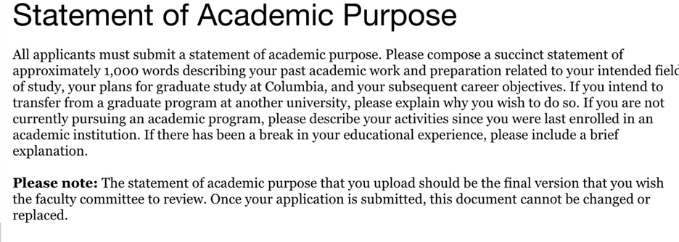

During my internship at Tencent Online Media Group in 2017, I leveraged my writing skills to produce hundreds of news stories for the Global News Channel. As a news writer, the most challenging parts are processing large amounts of information at a high speed while identifying and catering to user preferences. To overcome these challenges, I researched official and media reports to collate important global events scheduled to happen in the following month, so that I could be well-prepared to capture and log the events as they occur. Additionally, I paid close attention to user responses to my news articles including their comments and page views, which led to my discovery that Tencent users were into articles with visual aids and historical anecdotes. I shared my observations with my colleagues and improved my articles accordingly, whose views reached almost fifty times the number of our subscribers at the time. I was impressed by the power of understanding human decisions in order to increase product or service effectiveness, and started to wonder how this process could be automated through machine learning algorithms.

In an effort to gain more laboratory experiences, I found the opportunity to work as a research assistant at the Media Neuroscience Lab at UCSB, where I had my first exposure to rigorous scientific experiments involving data analytics. My main duties at the lab included assisting with two ongoing projects, one of them was a Functional magnetic resonance imaging (fMRI) study aimed at investigating brain networks underlying cognitive and perceptual processing during video game play, and the other focused on developing a narrative analysis system so as to examine the dynamics between moral domains in mediated narratives and audience response. I learned how to set up fMRI, run participants at the computer lab, and also code categories of moral information in news data using Excel. Most importantly, I was able to acquire valuable insights into how automated computational methods and hand coding could be used for content analysis of news articles, as well as how neuroimaging technology could be harnessed to enrich mass communication research from a neurophysiological perspective.

During the summer of 2018, I took the course on Laboratory in Advanced Research Methods, which brought me my first hands-on experience in conducting independent research study. I led a group of four people in the class to investigate the relationship between perceived self-esteem and likability of online profiles in an online dating context, with raters’ gender and own self-esteem as two moderators. We worked step by step from brainstorming research topics, literature review, experiment design, participants recruitment, data analysis and visualization using SPSS, to final research paper writing and poster presentation. Other than solid research knowledge and analytics skills, I realized that a willingness to iterate repetitive tasks to see a project to completion is crucial to any researcher. I did enjoyed deeply every minute working on our group project, which was eventually chosen as a class example.

Intrigued by the use of lab experiments to establish causal inferences, I started my own research project under the supervision of Dr. Rene Weber at the Media Neuroscience Lab. As a bilingual, I am interested in how juggling two tasks involving media use in different languages affect task performance among bilingual college students. During the literature review, I realized that this area of research is in its incipient stages and thus decided to design an exploratory study. I constructed an online picture-word matching task accompanied by audiobook clips in English, Mandarin and Spanish using PsychoPy, a software package in Python. To smooth the designing process, I programmed an image sorter that could extract words from file names to help me organize numerous pictures. So far, I have collected data on 80 participants and I am currently in the process of data analysis using the statistical program R. An extended abstract of the study has been submitted to International Communication Association and findings will be presented at ICA’s 2019 conference in May. I am hoping the study could help inform better media using behaviors among bilinguals and provide customer insights for digital media companies. This research experience has honed not only my presentation skills but also my research skills in gathering and analyzing information as well as formulating and testing hypothesis.

Other than my rich research experiences, my solid educational background has also prepared me well for the potential challenges of the QMSS program. Throughout my undergraduate years, I took a variety of courses that allowed me to gain a systematic understanding of psychology, neuroscience and communication from different perspectives, for example, organizational communication, small group communication, cognitive psychology and social networks. I was especially fond of the topics covered in the social networks class, where I was introduced to emergent structures, relational dynamics and networks across levels, types and contents. I am curious about ways to make use of the benefits this heightened connectivity has to offer to our society. If admitted, I plan to take advantage of the course on Social Network Analysis taught by the program director of QMSS, Dr. Greg Eirich, to receive high quality training on network analysis, manipulation and visualization using statistical software.

My distinguished scholarship along with my commitment to volunteer services has earned me high honors as well as the Academic Excellence Award upon graduation. In the hope of continue sharpening my quantitative skills, I have already started taking online courses in programming (R and Python), probability and data. Moreover, I aspire to further explore my current research topic on bilingualism and media multitasking, a near-ubiquitous behavior in the modern world. After reading the book on field experiments written by Dr. Donald Green and Dr. Alan Gerber during my junior year in college, I was attracted by the rich examples they provided from a variety of social science literatures and achieved a deeper understanding of field experimentation including its design, data analysis and results interpretation. I intend to learn more about field study approaches such as interviewing that can be incorporated in my current study to elicit detailed information from participants and acquire more in-depth insights into the topic.

My plan after graduating from QMSS is to pursue a doctorate in communication, where I can prepare myself for future careers in academia as university instructors while conducting original research with more sophisticated methods in the field of Communication with a focus on multimedia processing and cognitive responses to media effects. Given its extensive alumni networks and affluent academic resources, I have no doubt that QMSS at Columbia University will be an indispensable step towards my academic and career goals.